**User Manual**

**Home Page:**

User is provided with two options

1. User can Create Quiz => By selecting **Create Quiz** Button
2. User can Take => By selecting **Take Exam** Button

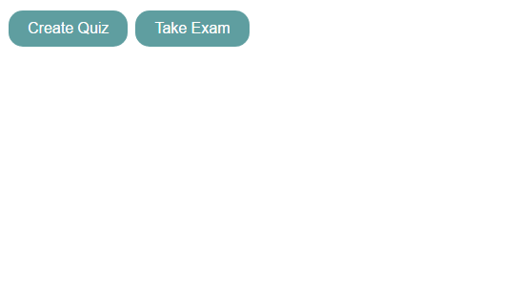

**Create Quiz:**

* User must Save the settings (Quiz Options) on Left side In order to create Quiz
* Buttons **“Save Instructions/Add New Question/Publish Quiz”** will be disabled initially

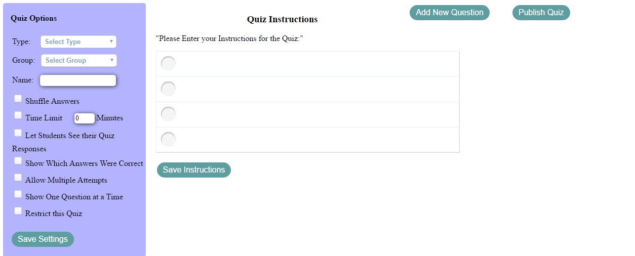

* Here Type/Group/Name are mandatory in order to create Quiz
* If **“Save Settings”** is Clicked without selecting/Entering above fields, User is prompted with Error Messages in (Error Panel)

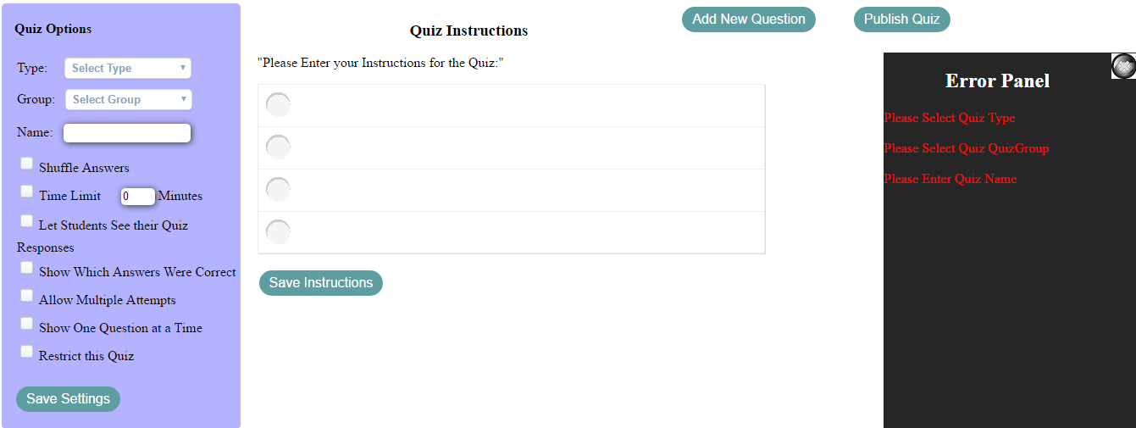

* Error panel gets disappeared on click of Cancel (x) image on Error Panel.



* After Selecting (Type,Group,Name) and **Save Settings** Quiz settings are saved and user is provided with Information message on **“Information Panel”**
* **Quiz Settings** section (Left side) is disabled. And **Save Instructions** Is enabled

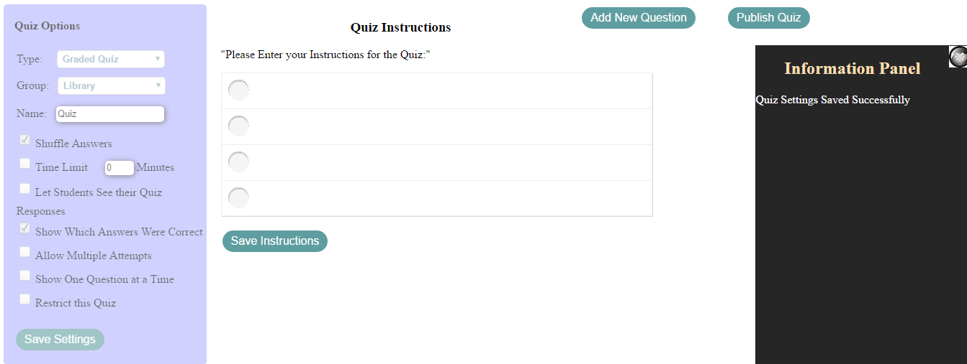

* Quiz Settings are saved in Database

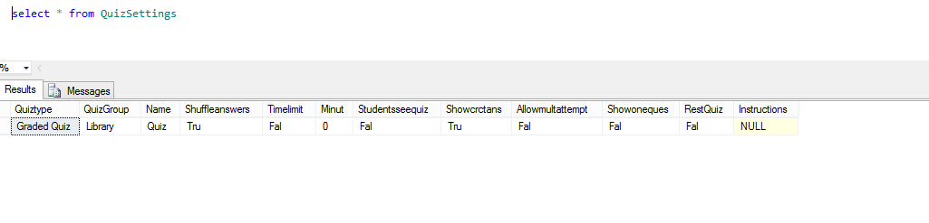

* User can enter Instructions and Click on “Save Instructions” button in order to save instructions.
* On Saving Instructions User is provided with Information message on **“Information Panel”**

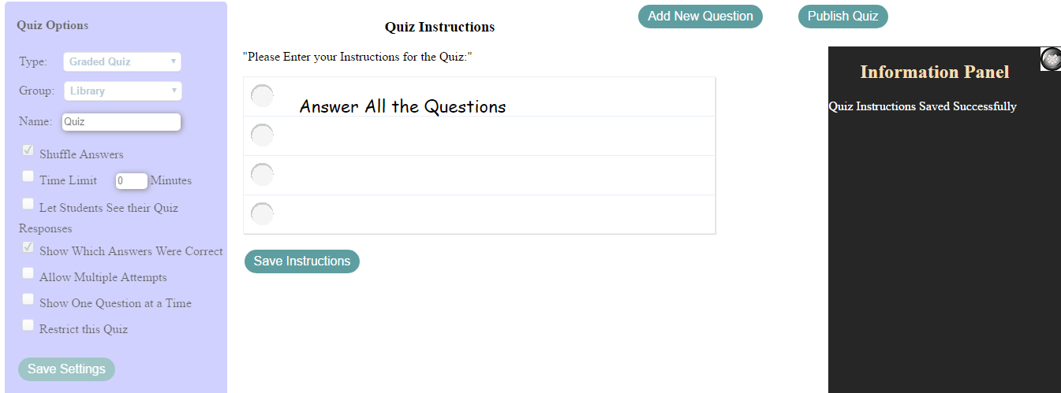

* Instructions Saved in Database

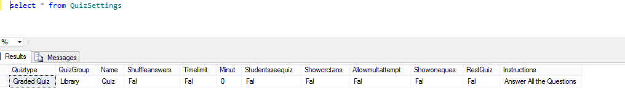

**Add Question:**

* On click of Add button user is provided with (Question, Points, Four Options) which are mandatory to Create a question

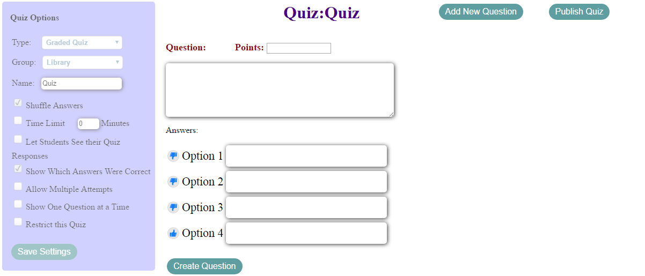

* On selection of “Create Question” without any data for above fields (Error Panel is displayed prompting user to Enter the required fields)

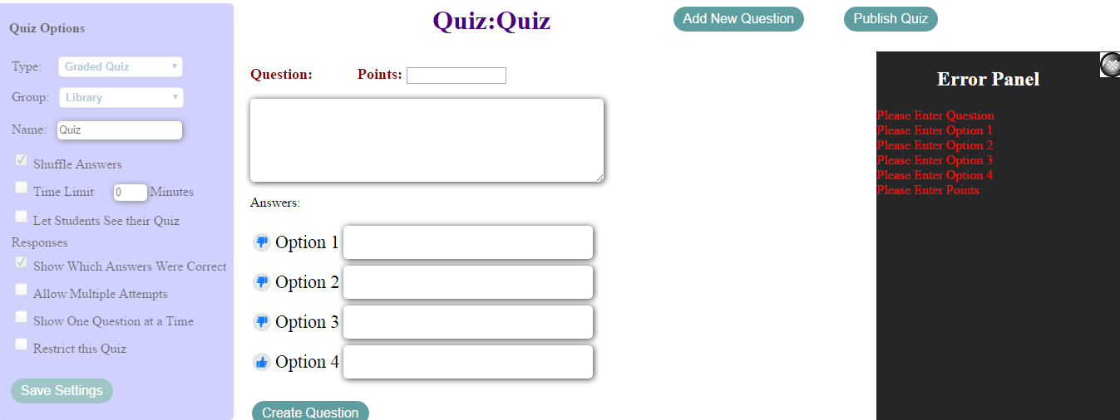

* User Can able to Create Question By entering required fields
* User must **like** the Appropriate Option for the correct Answer

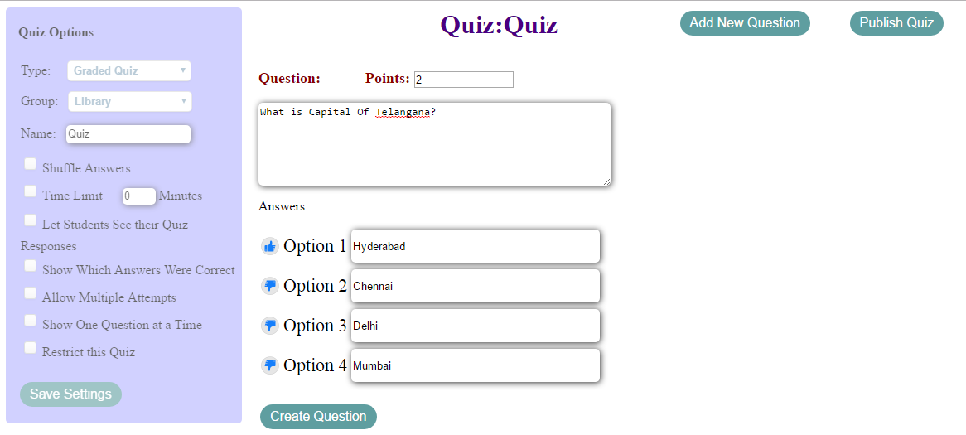

* After Creating the Question **“Edit Questions”** panel is displayed and Questions can be edited by selecting the Question from the panel
* Now After creating minimum of 1 Question **“Publish Quiz”**

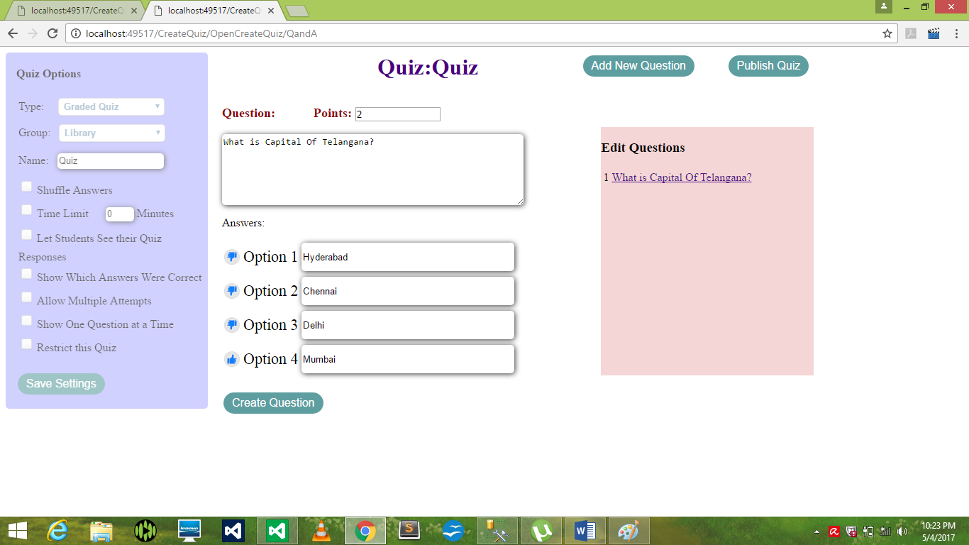

* New Question can be created by selecting “Add New Question” button
* Let Us create 5 Questions

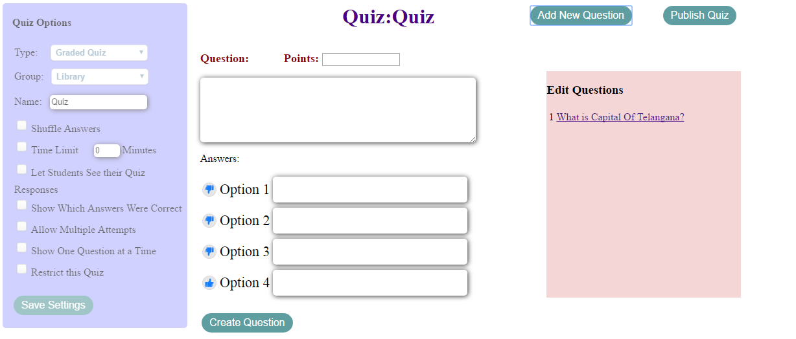

**Question 2:**

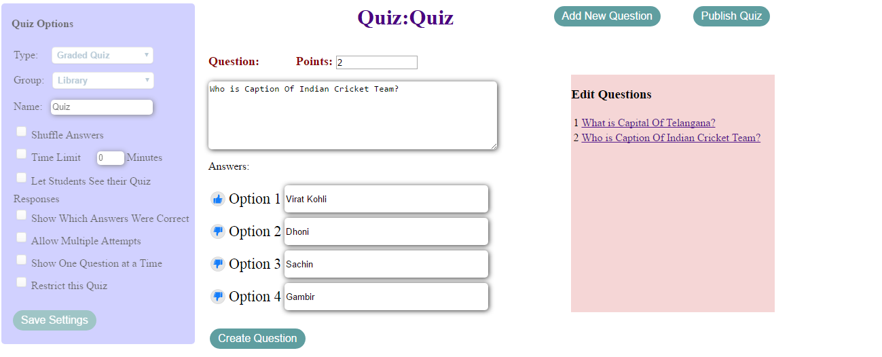

* 5 Questions are created.

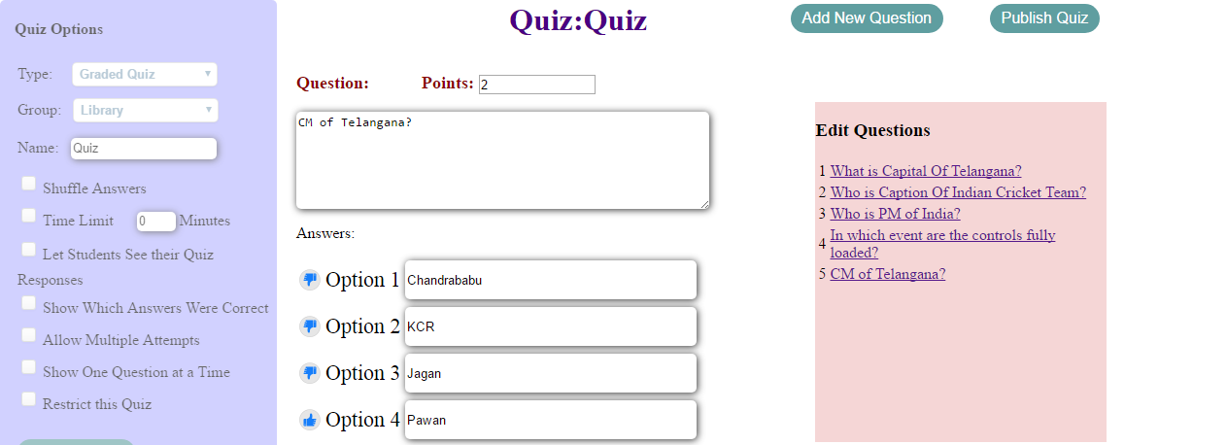

* User can click on Question in Edit Questions panel to update questions
* Let us select Question 5
* User can Update the fields and update

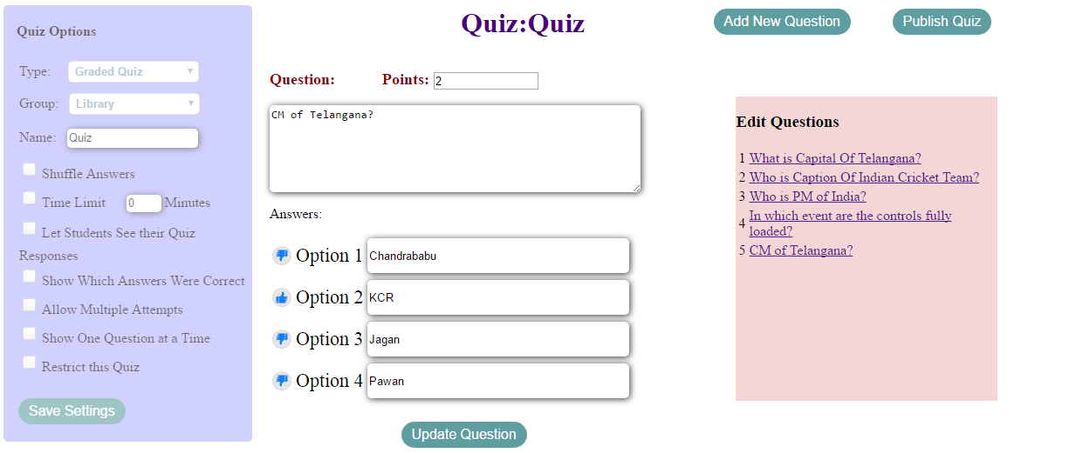

* Data is stored in Database

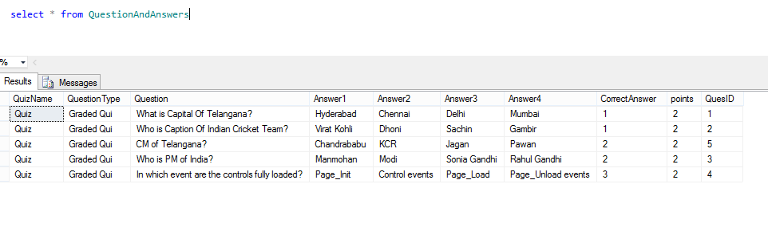

* Finally Publish the Quiz by clicking on **“Publish Quiz”** button
* User is Navigated to Home page



**Take Exam:**

* User can take Exam by clicking on **“Take exam”** button
* User can select the available quizzes from dropdown and click “Take Exam” button to take a test for particular Quiz

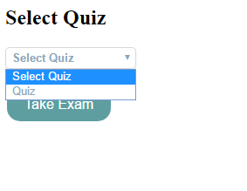

* Question 1 (Correct Answer Is selected)

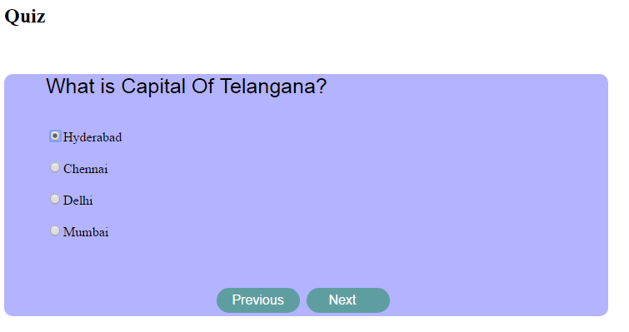

* Question 2 (Wrong answer is selected)

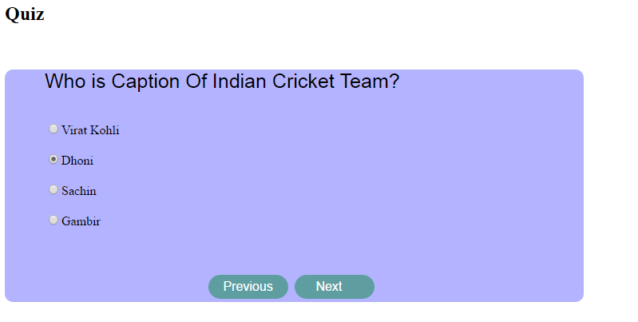

* When Previous button is clicked user will be navigated to previous question



* Question 3 (Correct Answer is selected)

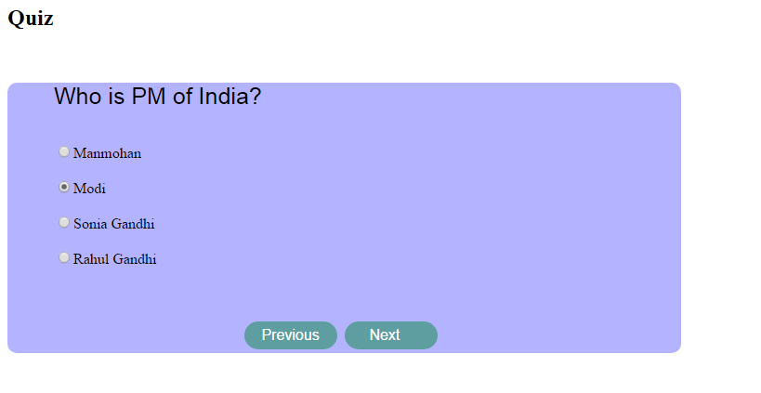

* Question 4 is unanswered

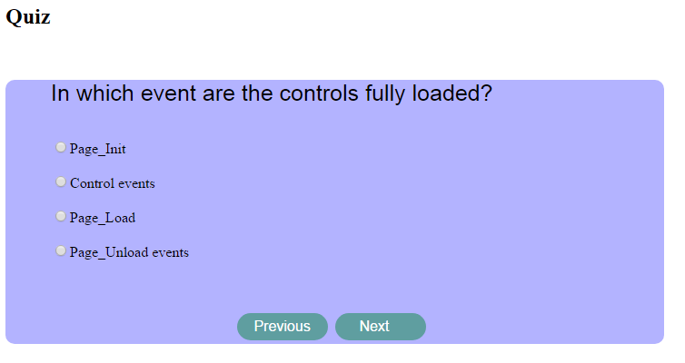

* Question 5 (Wrong answer is selected)

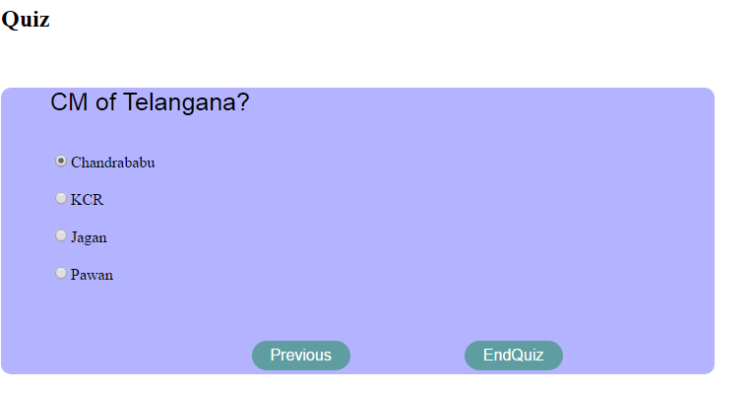

On selection of “EndQuiz”

* Score is calculated with detailed data. (Correct/Wrong/Unanswered)

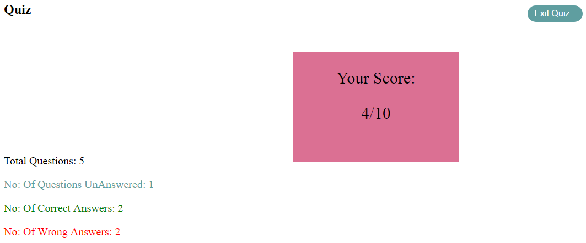

* Finally on click of **“Exit Quiz”** user is navigated to home page
* 